PRELAB!
Read the Mini-Project lab document and complete as much of the answer sheet as you can before lab.

1.0 Objective
The objective of this lab is to gain experience with the digital circuit design process. You will be given a non-functional circuit and you will be asked to redesign it so that it meets its intended specification, which is to detect 4-bit prime numbers.

2.0 Setup
Begin by creating a new folder U:\Documents\CPRE281\mProj. You will be saving your work for this lab in this directory. Information about the DE2-115 board, such as hardware device pin assignments, can be found in the user's manual provided with the Lab05 files. An excerpt from the user’s manual containing only the pin assignment information is also available with the Lab 03 files.

3.0 Overview
In this lab, you will be working with two functions, B(W, X, Y, Z) and P(W, X, Y, Z).

The first function, B, is given to you as a NAND circuit diagram. It is supposed to implement a 4-bit prime number detector, meaning it should output a 1 if the 4-bit input number is prime, and a 0 if not. However, for some input cases the circuit outputs the wrong value.

The second function, P, is the correct 4-bit prime number detector, for which you will create the complete truth table. You will then implement P in two different ways, first from scratch and then by adding additional logic to correct the B function for the cases in which it is incorrect.

Note: A prime number is a positive integer with no positive divisors other than 1 and itself. The number 1 is not considered prime.

4.0 Uncle Bob’s Circuit: NANDs to ANDs/ORs/NOTs
Uncle Bob calls you one evening and tells you that he has created a useful digital logic circuit. He has mailed you a package which you received earlier in the day. You open the package to find a logic circuit as well as a schematic detailing its design. Uncle Bob asks you to guess the circuit’s purpose. The circuit is seen in Figure 1.

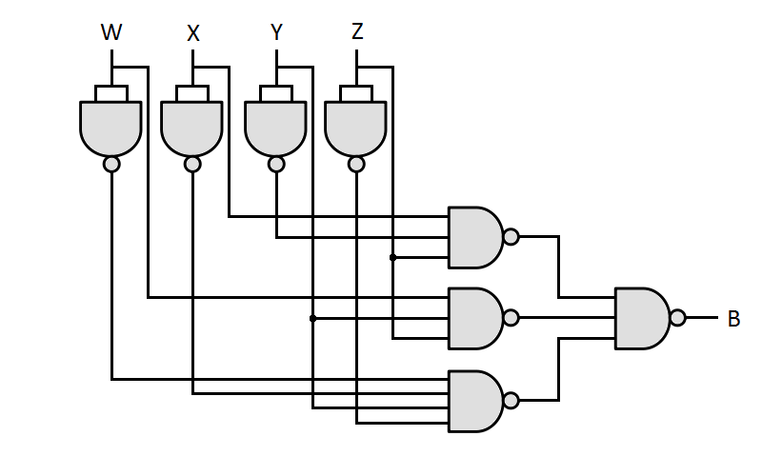
Figure 1 – Uncle Bob’s Circuit

Convert Uncle Bob’s circuit diagram, which uses only NANDs, to an equivalent circuit which uses only ANDs, ORs, and NOTs. Draw your circuit on the answer sheet.

5.0 Implementing From Canonical SOP
If you did section 4.0 correctly, your schematic should be a canonical SOP circuit. On the answer sheet write down the canonical SOP expression for this circuit using shorthand (i.e. sigma) notation.

Next, implement Uncle Bob’s circuit in Verilog as an SOP expression. Use behavior Verilog and a single assign statement. Program the FPGA board and demonstrate the results to a TA, assigning pins as necessary. Write or attach the completed Verilog function on the answer sheet.

6.0 Prime time: Debugging Function B
You tell Uncle Bob that the circuit does not appear particularly useful. He is a bit disappointed and tells you that the circuit should determine if a 4-bit input number is prime. That is, the circuit outputs 0 if the 4-bit number formed by the inputs is not prime and 1 if it is prime.

You check the output behavior of Uncle Bob’s circuit and observe that it outputs the wrong value in some cases. You are determined to fix it. Write out the truth table for Uncle Bob’s function B side-by-side with the truth table of the correct 4-bit prime detector function P that you will soon design. With the functions side-by-side, you should see several discrepancies between the two functions.

Next, fill out the K-map of P, and use it to find a simplified SOP expression for the function. Write the expression on the answer sheet.

7.0 Reimplement Function P
Implement the correct 4-bit prime number detector P from scratch using the truth table and simplified SOP expression. You may use either Verilog or schematic design. Include this implementation with your answer sheet, then demonstrate the results to the TA.

8.0 Add Corrective Logic to Fix B
The circuit you simulated on the board is nice, but you can’t give it to Uncle Bob. It would hurt Uncle Bob’s feelings if you didn’t somehow incorporate his design into your final circuit. So, you decide to create an additional design that uses Uncle Bob’s circuit.

Design and implement a circuit that uses Uncle Bob’s circuit but fixes his mistakes. Your design should include Uncle Bob’s function B and a minimal number of other gates or multiplexors.

Note: Your design should not include a full implementation of the correct function P. Think about how you can work with B and correct the specific cases in which the output is incorrect. A multiplexor or XOR gate may prove helpful in your design.

Create a symbol file for Uncle Bob’s function B that you implemented in Verilog previously. Use this symbol in your design.

Draw your new circuit on the answer sheet. Then, implement the design and demonstrate the results.

9.0 Complete
You present Uncle Bob with the corrected prime detector circuit. He is impressed by your efforts and says he’ll put in a good word for you at his company.

You are done with this lab. Ensure that all lab files are closed, exit Quartus Prime, log off the computer, power down the DE2-115 board, and hand in your answer sheet. Don’t forget to write down your name, student ID, and your lab section number.

