PRELAB!

Read the entire lab, and complete the prelab questions (Q1-Q4) on the answer sheet before coming to the laboratory.

1.0 Objective
In Lab 05, we created a circuit to display a 4-bit digital input (set on a set of toggle switches) onto a 7-segment display. In this lab we will perform addition of two 4-bit binary inputs and display the answer in decimal onto two 7-segment displays. (NOTE: All binary numbers in this lab are in unsigned representation.)

2.0 Setup
Refer to Figure 1. We will use the toggle switches available on the DE2-115 board to provide two 4-bit inputs. Each set of four switches represents one binary number. The inputs are wired to a block that adds the two numbers together. The result is processed to convert the results into two decimal digits (binary coded decimal or BCD representation is used for this purpose). For example, if we add number 7 (binary 0111) and number 5 (binary (0101), the result is 12, and it is displayed as two decimal digits 1 and a 2 after converting the result into two decimal digits using the module BCD_converter block. The two decimal digits are fed to their respective 7-segment display. The two 4-bit inputs are also displayed using two 7-segment displays.

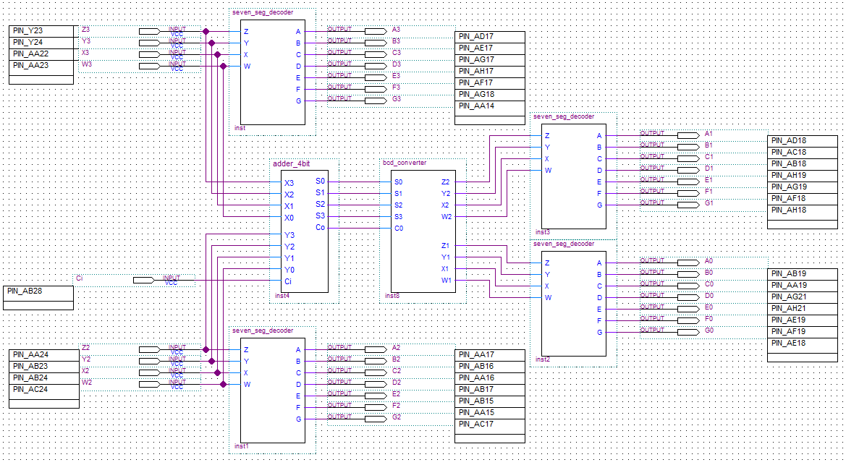
Figure 1: Adder with BCD Display

3.0 The Design

3.1 The 7-Segment Code Converter (seven_seg_decoder)
Use the 4-bit input 7-bit output seven segment decoder from Lab05 to display the 4-bit number onto a 7-segment display. Copy the .bsf and .v files for the symbol you want to use into your project folder.

NOTE: Recall from the last lab that it was tedious to create and assign all inputs and outputs. Therefore, rather than adding new symbols in the same way you add any new component, it is easier to copy the work you already have done and reuse it.

To do this, just open your lab5step1.bdf file. Select all of the components and wires. Then simply copy (Ctrl+c) them. Then in your current design simply paste (Ctrl+v) them. It is important that you copied the .bsf and corresponding .v file to your project directory so that your design will compile. Compile your design once and fix any errors you might have before copying over the pin assignments.

Quartus Prime stores the pin assignments in a .qsf file. Go to your lab5step1 directory and open the lab5step1.qsf file with a text editor such as Notepad++. Select the pin information and copy it as shown in Figure 2.

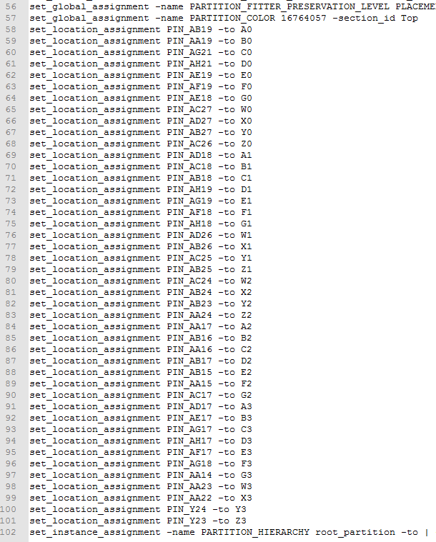
Figure 2: lab5step1 Pin Information
Next go to your Lab06 project directory and open the .qsf file there in a text editor. Paste the pin assignment information into the end of the file and save it. Then compile your design again. Now you are ready to modify your design by adding the last two components.

3.2 The 4-bit Adder
In this lab, you will a 4-bit adder that you have not implemented yet. It is provided to you. Download full_adder.bdf and adder_4bit.bdf, as well as their respective .bsf files, to your Lab06 directory from the files provided in your lab assignment folder. The full adder is used by the 4-bit adder to do the addition. The function of this block is to add two 4-bit numbers. Its output is a 4-bit number and a “carry-out bit” C0, or in other words, a five-bit number. The “carry-in bit” Ci, is assigned to SW0.

3.3 Binary Coded Decimal Converter
This block converts the adder output into two decimal digits, each of which is represented using 4-bits, and thus produces eight outputs for the two 7-segment displays. This block is created using verilog as part of Prelab Q4.

3.4 Test the BCD Adder
Perform the additions you carried out in the prelab to test your circuit. Demonstrate your design to your TA.

5.0 Complete
You are done with this lab. Ensure that all files are closed and then exit Quartus Prime. Log off the computer, power down the DE2-115 board, and hand in your answer sheet to your TA. Don’t forget to write down your name and your lab section number.

