PRELAB!

Read the entire lab, and complete the prelab questions (Q1-Q3) on the answer sheet before coming to the laboratory.

1.0 Objectives
In this lab you will get familiar with the concept of using the computer as an experimental tool, to enforce the theory learned in class. You will also have an introduction to the CAD (computer aided design) tool we will be using in this course: Altera Quartus Prime. And, you will learn to use truth tables, logic expressions, and circuit design. We will apply the knowledge using the DE2-115 board to observe how these concepts relate to each other.

2.0 Setup
The laboratory is equipped to provide hardware and software needed to perform the labs. A TA should also be present and is a good resource for questions. The time you spend in lab will be more productive, and you will have a better lab experience if you read, and complete, as much of the lab as possible before you arrive. When you arrive at the lab you should find an available desktop computer. You should also have a lab answer sheet. Record your answers to the questions on the answer sheet and then hand it in when the lab is completed (don’t forget to write your names).

To begin, create a file folder for CPRE 281 inside your network drive directory (U:\ Drive). Each lab will eventually have its own subfolder inside U:\CPRE281.

Download zipped lab files from the course webpage on Blackboard/course website and extract the files into U:\CPRE281. Now you should have path U:\CPRE281\Lab01 for Lab #1 files in your network drive directory. Ask your TA if you need assistance.

You are ready to run Quartus Prime software. Click on the Windows Start Button, go through Altera 16.1.0.196 then click on Quartus Prime 16.1 to run the software. This is the software we will be using for the rest of the semester.

Open a file in Quartus Prime
- Left-Click on the Open File icon from the icon bar (second icon from your left), or select File>Open Project from the dropdown menu.
- Click on the downward arrow in the Address bar box. Make sure the directory looks like U:\CPRE281\Lab01\...\lab1step1; navigate to the file from the U:\ via “This PC” if it does not. It is important that the address begins with U:\ and not “\\my.files.iastate.edu\”; Quartus 16.0 will not compile from filepaths that begin with the latter.
- Select lab1step1.qpf (ensure the file extension is .qpf, otherwise you will not be able to compile) and click Open.
- Click Yes on the Dialog box to upgrade project if it opens up.

A simple AND circuit
- The circuit has already been started for you, and it should have two inputs labeled A and B, and is missing an output. Double-click on the lab1step1 icon in the Project Navigator window to view the Block Design File (lab1step1.bdf).
- In order to create the output pin double click on the blank area to the right of the circuit. This will bring up the Symbol dialog. In the Name field type “output” and then press OK. Left-click to place the output pin on the diagram.
- The pin can be renamed by double-clicking on the pin (you may also right click on it select Properties). Rename the output pin to C.
- Connect pin C to the output of the AND gate by dragging it over so that the pin touches the output of the AND gate and releasing it. Then you can grab it again and move it away from the AND gate and a wire should appear connecting the two.

Compile the circuit
- Select Processing>Start Compilation (save your changes if prompted).
- A warning dialogue box may pop up when the compilation is finished. Ignore the warnings for now and click the OK button. If you have any other errors fix them now.

3.0 Hardware Testing – DE2-115 Board
The DE2-115 board contains a Field Programmable Gate Array (FPGA). This chip is a fabric of gates that can be programmed in order to create digital circuits. The FPGA can be programmed with the digital circuit you just created. The DE2-115 board also contains a variety of switches, LEDs, an LCD, seven segment displays, and many other I/O devices. The FPGA is directly connected to the devices on the DE2-115 board. By assigning the appropriate pin on the FPGA your circuit can be wired to the various I/O devices. For example, you can wire the toggle switches to the inputs of your circuit, and an LED to the output of your circuit.

Make sure that your DE2-115 board has 12V DC Power connected, and the USB cable connected to the USB Blaster Port. Then turn ON your board. Also make sure that the RUN/PROG switch on the board is set to RUN. The PROG selection is only used for active serial programming (AS mode), and we need to be in JTAG mode which is the RUN selection.

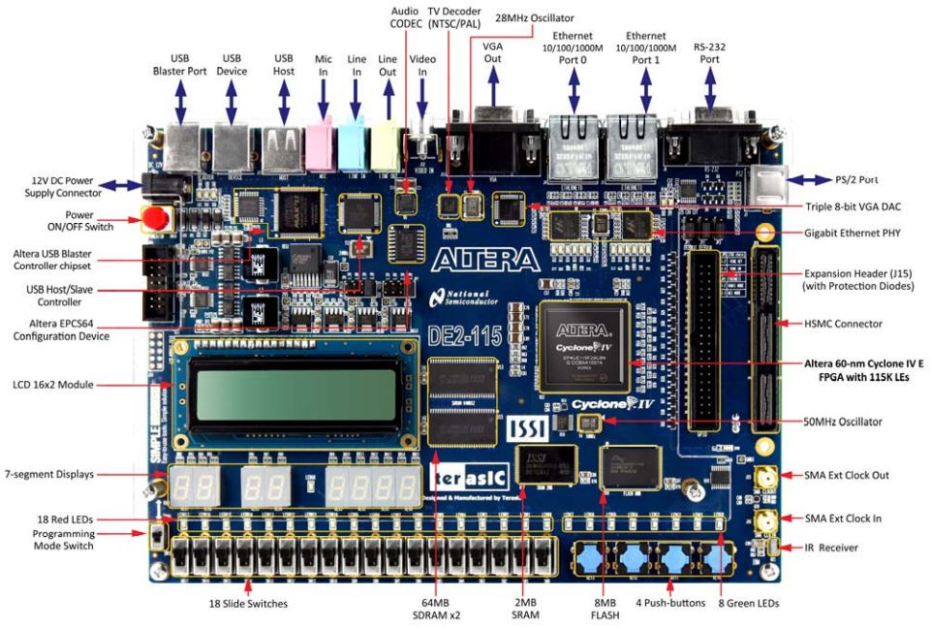

DE2-115 Specifications

FPGA
- Cyclone IV EP4CE115F29C7 FPGA and EPCS64 serial configuration device

I/O Devices
- Built-in USB Blaster for FPGA configuration
- 2 Gigabit Ethernet, RS-232, Infrared receiver
- Video Out (VGA 8-bit DAC)
- Video In (NTSC/PAL/SECAM/Multi-format)
- USB 2.0 (type A and type B)
- PS/2 mouse or keyboard port
- Line-in, Line-out, microphone-in (24-bit audio CODEC)
- Expansion header (38 signal pins)
- Mezzanine card

Memory
- 2 64-MB SDRAM, 2-MB SRAM, 8-MB Flash
- SD memory card slot

Switches, LEDs, Displays, and Clocks
- 18 slide switches
- 4 debounced pushbutton switches
- 18 red LEDs, 9 green LEDs
- Eight 7-segment displays
- 16 x 2 LCD display
- 50-MHz oscillator, 2 external SMA clock input/output

Assigning Pins
- Open the Pin Planner - Assignments>Pin Planner.
- Double-click in the Location cell for input pin A. This should bring up a drop down menu. Select PIN_AB28 then press Enter. PIN_AB28 is connected to the toggle switch SW[0] on the DE2-115 board.
- In the same manner assign pin B to SW[1] which is PIN_AC28 on the FPGA, and assign the output pin C to the green LEDG[7] which is PIN_G21 on the FPGA.
- Close the Pin Planner and compile the circuit again.

Programming the FPGA
- Open the Programmer – Tools>Programmer.
- Click the Hardware Setup… button.
- Under Currently selected hardware: select USB-Blaster [USB-0] and click Close.
- If your window looks like the one below click on the Start button.

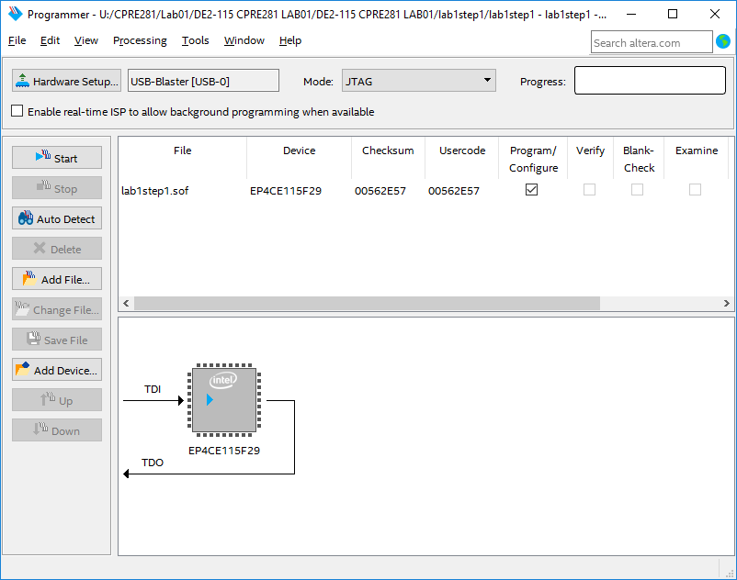

When the green LOAD LED (adjacent to the blue POWER LED) extinguishes, the FPGA will be programmed with your digital circuit. You may now test the behavior of your circuit. The Answer Sheet has a Truth Table for this circuit. Toggle the switches (inputs) and observe the LED (output). Record the results for the circuit’s output on the right column of the Truth Table. When you are done, review your results with the TA, and have the TA sign his/her initials on your sheet. Finally, close the lab1step1 project.

4.0 Multi-level Circuits
We will now look at a more complex circuit. Open the (*.qpf) files and follow the instructions. Read the previously outlined steps for opening a file if you are not sure how.

Circuit 1
  - Open the lab1step2.qpf file. Even though this circuit is larger, its behavior can still be shown on a Truth Table. The circuit has multiple logic gates, a single output, and three inputs. You do not have to add anything to this circuit. Notice that pin W is assigned to SW[2] which is PIN_AC27 on the FPGA.
  - Compile the design and then program the FPGA with the new circuit. Record the circuit’s behavior on your answer sheet.

You can discuss the results with your TA. When you are done, have the TA mark his/her initials next to your answers.

Circuit 2
  - Open the lab1step3.qpf in Quartus Prime. Notice that the Truth Table on the answer sheet for this circuit is blank.
  - You need to fill in all possible input and output combinations in the Truth Table.
  - Use the DE2-115 board to toggle the inputs on the gates to determine how the input combinations affect the output.
  - Record each input combination and resulting output.

You can discuss the results with your TA. When you are done, have the TA mark his/her initials next to your answers.

5.0 Complete
You are done with this lab. Ensure that all lab files are closed. Exit Quartus Prime, log off the computer, power down the DE2-115 board, and hand in your answer sheet. Don’t forget to write down your name, student ID and your lab section number.

