Name and Student ID:________________________________________ Lab Section:__

Date:_________________

PRELAB:

Q1. Circuit diagram for a register file with four 2-bit registers.
Please complete the following circuit diagram to implement a register file with four 2-bit registers, one write port, one read port, and one write enable line. Label all inputs and outputs of your circuit. Please use different colors for the different types of wires.

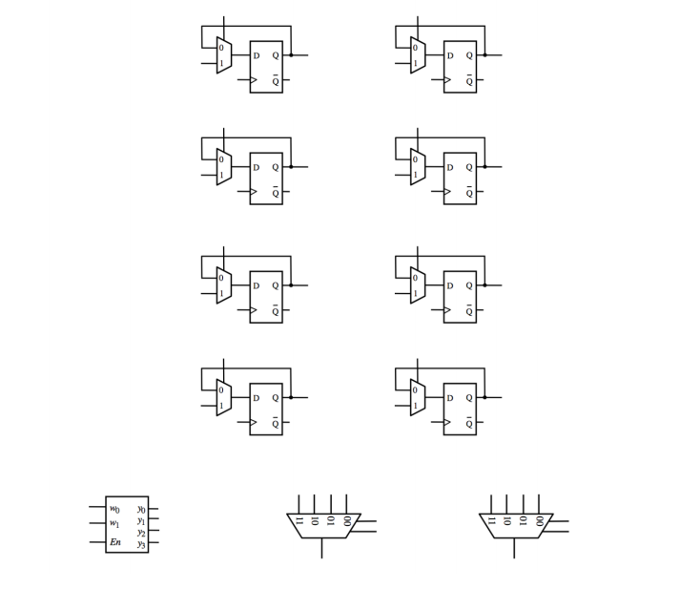

The rest of this lab is about a register file with eight 4-bit registers.

Q2. Draw a schematic diagram for a 4-bit register using four D Flip-Flops and four 2-1 multiplexers. Draw a block around each one-bit register used in your design.

Q3. Write the Verilog code for a 4-bit 8-to-1 multiplexer below.
module Mux8_4b(S2, S1, S0, W0, W1, W2, W3, W4, W5, W6, W7, F);
input S2, S1, S0;
input [3:0] W0, W1, W2, W3, W4, W5, W6, W7;
output [3:0] F;

Q4. Write the Verilog code for a 3-to-8 decoder in the space below.
module Decoder3to8(EN, W2, W1, W0, Y0, Y1, Y2, Y3, Y4, Y5, Y6, Y7);
input EN, W2, W1, W0;
output Y0, Y1, Y2, Y3, Y4, Y5, Y6, Y7;

Q5. Using copies of the decoder, multiplexer, and 4-bit register from the previous steps, write the Verilog code that will provide the functionality of a register file with eight 4-bit registers. Your code should contain the decoder, the 4-bit registers, the multiplexers, and additional connections to make the whole circuit operational.

module regfile(DATAP3, DATAP2, DATAP1, DATAP0, DATAQ3, DATAQ2, DATAQ1, DATAQ0,
RP2, RP1, RP0, RQ2, RQ1, RQ0, WA2, WA1, WA0, LD_DATA, WR, CLRN, CLK);

// address and control ports
input RP2, RP1, RP0, RQ2, RQ1, RQ0, WA2, WA1, WA0, WR, CLRN, CLK;

// input data port
input [3:0] LD_DATA;

// output data ports
output DATAP3, DATAP2, DATAP1, DATAP0, DATAQ3, DATAQ2, DATAQ1, DATAQ0;

// wire declarations
wire [3:0] DATAP, DATAQ;

Prelab TA Initials: _________
LAB:

Fill in the characteristic table for the one-bit parallel access register.
In | Load | Out
0 | 0
1 | 0
0 | 1
1 | 1

Fill in the table with steps that will load the registers as follows: Reg[0]=F, Reg[1]=A. Reg{2]=C. Reg[3]=E, Reg[4]=2, Reg[5]=7, Reg[6]=6, and Reg[7]=1.
LD_DATA | WA

4.0 Register File with Eight 4-bit Registers

Hardware demonstrates a good circuit. TA Initials: _________

Fill in the table below with the result produced by the register file (with CLRN=1).

LD_DATA | Sel | WA | RP | RQ | CTRL | WR | Effect
0110 | 0 | 111 | 111 | 111 | 0 | 1 | Reg[7] 6.
0011 | 0 | 110 | 110 | 111 | 0 | 1
0010 | 0 | 101 | 101 | 110 | 1 | 1
0100 | 0 | 100 | 100 | 101 | 1 | 1
0101 | 0 | 011 | 011 | 100 | 0 | 1
0001 | 0 | 010 | 010 | 011 | 0 | 1
0111 | 0 | 001 | 001 | 010 | 1 | 1
1000 | 0 | 000 | 000 | 001 | 1 | 1 | Register File Contents:
0000 | 1 | 001 | 000 | 001 | 0 | 1
0001 | 1 | 000 | 010 | 011 | 0 | 1
1111 | 1 | 010 | 100 | 101 | 1 | 1
1001 | 1 | 101 | 110 | 111 | 1 | 1
0100 | 1 | 010 | 010 | 101 | 1 | 0 | Register File Contents:

5.0 Register File with Adder and 7-Seg Displays

Hardware demonstrates a good circuit. TA Initials: _________

