PRELAB!

Read the entire lab, and complete the prelab questions (Q1-Q2) on the answer sheet before coming to the laboratory.

1.0 Objectives
In the last lab, we learned how to use schematic capture to design digital circuits in Altera Quartus Prime. The steps performed were: understanding the problem statement, deriving a logic function, drawing the logic expression using logic gates (NOT, OR, AND), naming the inputs and the output, and finally using the FPGA and/or ModelSim to verify the circuit for all possible values of the input. This lab is similar; however, we will take a different approach. We will write Verilog code to describe the logic expression instead of drawing the logic gates.

2.0 Setup

2.1 Verilog
At this point, you might be asking yourself, “What is Verilog, anyway?” First, you have to know what a Hardware Description Language (HDL) is. HDLs are used to perform a logic synthesis of a design. That means we write a code describing our logic and the HDL compiles it to create the adequate circuit diagram. This simplistic definition is very powerful and tells us that now we can just “code” our logic, and we will get the equivalent circuit, without going through the hassle of drawing it. Verilog is an HDL that is used widely throughout the US industry since it went open-source in 1990. It is portable in nature, meaning that the same code can be used in different CAD tools. Just like any coding language, it has a compiler, libraries, syntax, commenting, etc. There exist many HDLs besides Verilog. The most popular among others is VHDL (V stands for Very High Speed Integrated Circuit), and is used in most industries in the rest of the world.

More information on Verilog can be found in http://www.verilog.com/ and in your textbook.

2.2 Structural coding
When we look at the structural level of a design, we are interested in how each variable is processed before a design produces an output. For example, in implementing the expression, we will first INVERT C, AND it with B, and then OR the result with A.

The Verilog code for F is as follows:

module structural_example (F, A, B, C);
input A, B, C;
output F; /*always comment your code
so you know what you did!*/
/* This code define the structure of the circuit */
/* First symbol is always output for not, and, and or */
not (D,C); //C is inverted and stored in D, output is named
and (E,B,D); //B AND with D, store result in E, output is named
or (F,A,E); //A OR with E, store result in F

endmodule

2.3 Behavioral Coding
Another way to generate a circuit is to study its behavioral description instead of its structural description. This implies that we are looking at our logic design from a system point of view, i.e. what the inputs are, what the outputs are, and how they are related to each other. This is usually a lot simpler to do than the structural description. It is faster in user time to design. Considering our previous example again, we could write the following code:

module behavioral_example (F, A, B, C);
input A, B, C;
output F; /*always comment your code
so you know what you did!*/

assign F=(A|(~C&B)); //write down the logic expression

endmodule

After this brief introduction to Verilog, we will get started on two design examples. For a more thorough reference on Verilog, read textbook.

2.4 Setup
Create a folder U:\Documents\CPRE281\Lab03, and four sub-folders \Lab03\lab3step0, \Lab03\lab3step1, \Lab03\lab3step2, and \Lab03\lab3step3. You will be saving your work and programming the hardware for this lab in these directories.

3.0 Design 1
You will design and verify the “farmer’s problem” describe below using Verilog. You will use the product-of-sums (POS) expression. You will run a schematic, a structural, and a behavioral description of the same problem. The goals of this lab session are:

- To learn use of Schematic Capture using POS expression.
- To learn use of Verilog Structural description.
- To learn use of Verilog Behavioral description.

For each design simulation, you have to show your simulation results and your code and/or schematic to the lab instructor to obtain their initials on your answer sheet.

Description:
A farmer owns two barns; one north of a creek and the other south. The farmer has a Cabbage, a Goat, and a Wolf. The Farmer needs to put each item in a barn every night. If the Cabbage and the Goat are in the same barn, the Goat will eat the Cabbage. If the Wolf and the Goat are in the same barn, the Wolf will eat the Goat. The Farmer is worried and you have to design an alarm circuit that will let him know if two items can safely be placed in a barn.
For this circuit, you have three and one.
If an input is in the north barn, it gets assigned logic 1, and if it is in the south barn it gets assigned logic 0. The output Alarm, asserts if there are two items in a barn that should not be kept together.

3.1 Schematic Capture with Quartus Block Design Files (lab3step0) and FPGA
In this step, you will use Schematic Capture with the FPGA to simulate the alarm circuit. This is the method we used to simulate the simpler circuit in Lab 2.
- Verify your logic expression for the alarm circuit.
- Open Quartus and create a project named lab3step0 and save it under U:\CPRE281\Lab03\lab3step0.
- Implement your Product-of-Sums logic expression in a BDF.
- Compile as necessary, assign pins, and program the FPGA.
- Verify your results and demonstrate the completed circuit to the TA.

3.2 Structural Verilog (lab3step1) and ModelSim
In this step, you will use Structural Verilog with ModelSim to simulate the Alarm circuit.
- To write Verilog code, use a text editor that generates plain ASCII text. Quartus Prime has one built-in editor that is recommended. Create a new project named lab3step1.qpf, and save your file under U:\CPRE281\Lab03\lab3step1.
- Then add a text file by going to File -> New under Design File select Verilog HDL File and save it as lab3step1.v (IMPORTANT: USE THIS NAME FOR YOUR FILE).
- Write a structural description for the farmer’s problem similar to what was explained in section 2.2. Again, you will have to use Product-of-Sums expression. Also, the name of your module function should be the same as the file name! This means your module for this step must be named as “module lab3step1(…);”. Otherwise, you will get an error (see below).
- When you are done writing your code, go to Processing -> Analyze Current File to analyze the file for syntax errors. If the option is greyed out, make sure you have lab3step1.v open. If you get errors, fix your code and, if needed, take a look at your textbook for more details on the syntax or ask your lab instructor.
- Next, simulate your design using ModelSim (refer to previous labs for detailed instructions, if necessary).
- Verify that you are getting the exact same output as in the schematic capture (notice that, if you keep the FPGA programmed from step0, you can compare the outputs directly). Show your simulation results to the TA.

3.3 Behavioral Verilog (lab3step2)
In this step, you will implement the alarm circuit using Behavioral Verilog.
- Repeat the previous Verilog steps, except this time you will use a behavioral description. Create a new project and name the Verilog file lab3step2.v. Look at section 2.3 for more info on the behavioral description.
- While you can manually simulate this Verilog file in Questa just as you did the previous one, you can also automate the simulation values by using a DO file. To create a DO file in ModelSim, go to File New Source Do. This will open a DO file text editor with context markup. For this step, write the following commands in the text editor:
force C 0 0, 1 200 -repeat 400
force G 0 0, 1 100 -repeat 200
force W 0 0, 1 50 -repeat 100

run 400
(Note that if your Verilog inputs are not named C, G, and W, then you will have to rename them here such that they are the same.)
- Save this file to the lab3step2 project folder as basic-alarm.do.

- Now, in Questa, after you have established waveforms for the inputs and outputs by selecting them all and pressing Ctrl-W, you can go to the command line and simulate the inputs by running your DO file with “do basic-alarm.do”
- Once all of your outputs are simulated correctly, show your code and results to the lab instructor.

3.4 Troubleshooting
Error: Can’t compile duplicate declarations of entity “filename” into library “work”.
This error is generally due to having two files with the same name as the project.
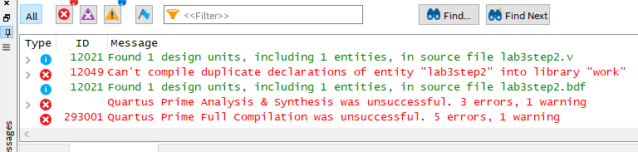
To fix this error, you can either:
- Make a new project and “Open existing file” to bring the old file into the new project
- Go to the Project Navigator window in the upper-left, change the “Hierarchy” box to view “Files”, right-click the file you don’t want to compile, and click “Remove File from Project”
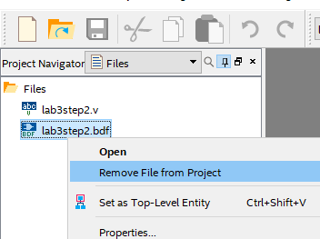
Error: Top-level design entity “filename” is undefined.
This error is due to not having a Verilog module match the name of the file, but also possibly due to having removed a top-level file and not creating another.
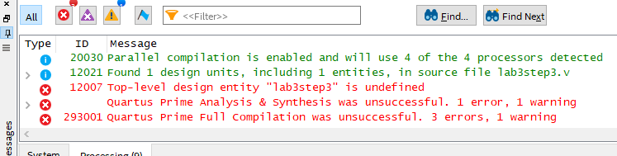

To fix this error, you can either:
- Rename the Verilog module to match the name of the project.
- Go to the Project Navigator window in the upper-left, change the “Hierarchy” box to view “Files”, right-click your ‘main’ file, and select “Set as Top-Level Entity”.

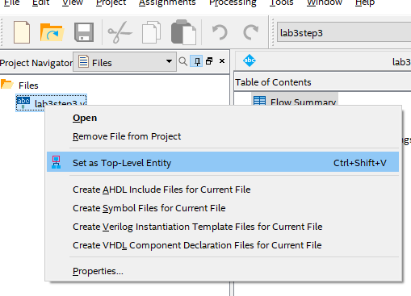
4.0 Design 2 (Lab3step3)
This time, we will make the farmer’s problem more complex by adding the farmer himself to the bunch. That way, his presence will keep the wolf from eating the goat, and the goat from eating the cabbage.
- First, write a canonical SOP expression. Record your expression in the lab report.
- Second, simplify this SOP expression and record this new expression in the lab report. This is the circuit that you will implement.
- Create a new project named lab3step3.qpf, and save your file under \CPRE281\Lab03\lab3step3.
- Use Verilog to create a digital circuit for the alarm. You can choose either the structural or the behavioral description.
- Use the DE2-115 board or ModelSim to verify your circuit operates properly. Show your results to the lab instructor.

5.0 Complete
You are done with this lab. Ensure that all lab files are closed, exit Quartus Prime and Questa, log off the computer, power down the DE2-115 board, and hand in your answer sheet. Don’t forget to write down your name, student ID, and your lab section number.

