Title of the Project
Subtitle of the Project (if any)

Firstname Lastname,
Firstname Lastname,
…
Firstname Lastname

Team Number ??

April 22, 2021

Final Project Report for
HCI 575: Computational Perception

Iowa State University
Spring 2021

ABSTRACT

Put your abstract here. This should be one paragraph or approximately 150 words.

1 Introduction

Text for the introduction. Use 1.0 line interval and 12-pt font size.

2 Related Work

Text for the related work, with references. Citation [1]. Citation [2, 3].

In this section you need to summarize the work of others that is related to your project. Even though this is the work of others, you need to explain it in your own words. For example, reference [2] describes a system for face detection that inspired this project. The main difference between[2] and this work is that here we …

“If you include text from other sources, then make sure to put it in double quotes and provide a reference after it” [4, p. 135].

3 Experimental Platform

Describe the equipment and the setup for your experiments. It would be helpful to add figures, diagrams, and pictures that capture the experimental setup.

Figure 1 illustrates the difference between polar and Cartesian coordinate systems. Make sure to cite the source for figures and pictures that you did not create.

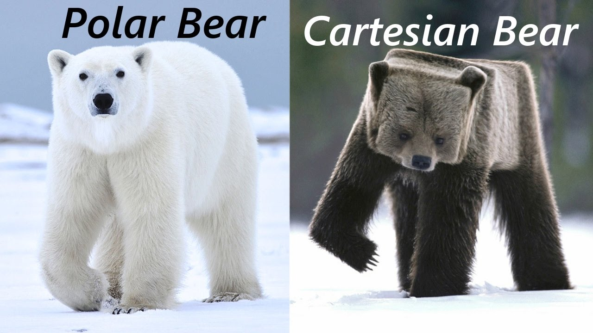
Figure 1: A very nice visualization of the difference between polar and Cartesian coordinates. (Image Credit: https://i.ytimg.com/vi/HcaTYrpmGaU/maxresdefault.jpg)
4 Methodology

Describe how the results were obtained. Algorithms, formulas that help explain what was done.

5 Results

Describe the results of the project. It may be helpful to split them into experiment 1, 2, 3. Add figures and tables to visualize the outcomes of the experiments.

As shown in Figure 2, all angles of an equilateral triangle are equal to 60 degrees.

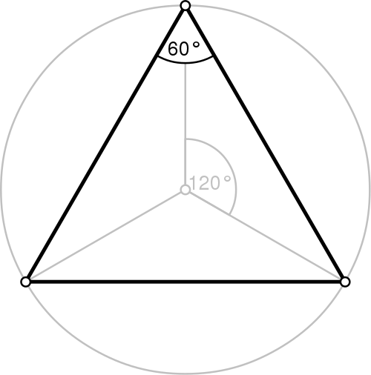
Figure 2. An equilateral triangle (from Wikipedia).

Table 1 shows the first three integer powers of the first three positive integers. The largest number in the table is 27.

n | n² | n³
1 | 1 | 1
2 | 4 | 8
3 | 9 | 27
Table 1. First, second, and third powers of the numbers 1, 2, and 3.

6 Discussion

Write a couple of paragraphs that discuss the results in the context of the overall objectives of the project. Did you accomplish what you wanted with the experiments? Were they too restrictive to claim success? If some experiment failed, then this might be a good place to explain/speculate why that happened and what would could be done to fix it or why it did not affect other results.

7 Conclusion and Future Work

Write two paragraphs that summarize your work and another two paragraphs that suggest potential future work that builds upon this project.
REFERENCES

[1] Lastname A., Lastname B., and Lastname C. Title of the paper. Name of the journal. Volume. Number. pp. 123–456. Year. Optional notes (e.g. “in French” or “See Fig. 7b.”).
[2] Lastname A. Book title (Publisher name. Publisher city and state/country. Month, Year). Edition if more than one edition. Optional Notes.
[3] Lastname A., Lastname B., and Lastname C. Title of a conference paper. In Proceedings of the 123-th ABC International Conference on XYZ. pp. 123–456. (City, State, Year). Notes.
[4] Lastname A., Lastname B, and Lastname C. Title of a book chapter. In Title of an Edited Book (Publisher name. Publisher city and state/country. Month, Year). pp. 123–456. Optional notes.
[5] Lastname, A. and Lastname B. Title of a web page. http://example.org/ (Date accessed).
[6] Lastname, A. et al. (use this for more than three authors). …
[7] Lastname, A. Title of a technical report. Institution. Identifier of the technical report. Year.
[8] Graduate S. Title of a PhD dissertation. Department name, University name. Year. Optional notes (e.g., “Chapter 3”).

APPENDIX A: Proof of Some Theorem
Formal proof of a theorem. Or anything else that would be a distraction in the main text. Make sure to cite this appendix in the main text (e.g., see Appendix A for the proof).

APPENDIX B: Source Code
Put the source for some key algorithms that you developed, used, or relied on in this project.

APPENDIX C: Additional Resources
Links to YouTube videos of your project, code repositories that were used, project website, etc.

