1.0 Objectives
In the past, we have been designing logic circuits and testing them on the DES-115 board or in simulation. While this allows you to rapidly test different designs, it is hard to see the physical interaction between the different gates. In this mini-lab, we will connect several TTL microchips together in order to create a physical implementation of the following logic expression:

$$f=x_{1}x_{2}+\overline{x_{2}}x_{3}$$

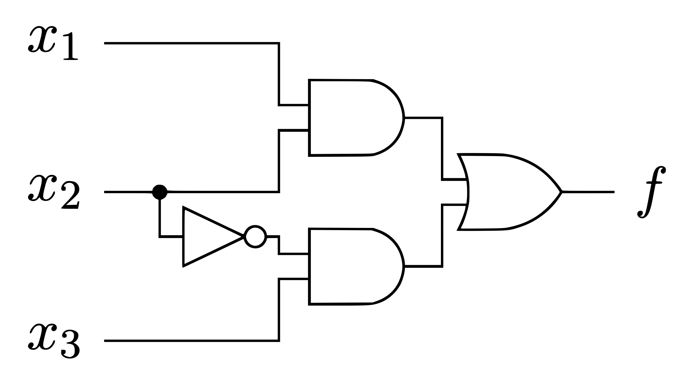

$$x_{1}$$ | $$x_{2}$$ | $$x_{3}$$ | $$x_{1}x_{2}$$ | $$\overline{x_{2}}x_{3}$$ | $$f= x_{1}x_{2}+\overline{x_{2}}x_{3}$$
0 | 0 | 0 | 0 | 0 | 0
0 | 0 | 1 | 0 | 1 | 1
0 | 1 | 0 | 0 | 0 | 0
0 | 1 | 1 | 0 | 0 | 0
1 | 0 | 0 | 0 | 0 | 0
1 | 0 | 1 | 0 | 1 | 1
1 | 1 | 0 | 1 | 0 | 1
1 | 1 | 1 | 1 | 0 | 1

2.0 Background

2.1 TTL ICs

We will be constructing a circuit based on this figure from the textbook:

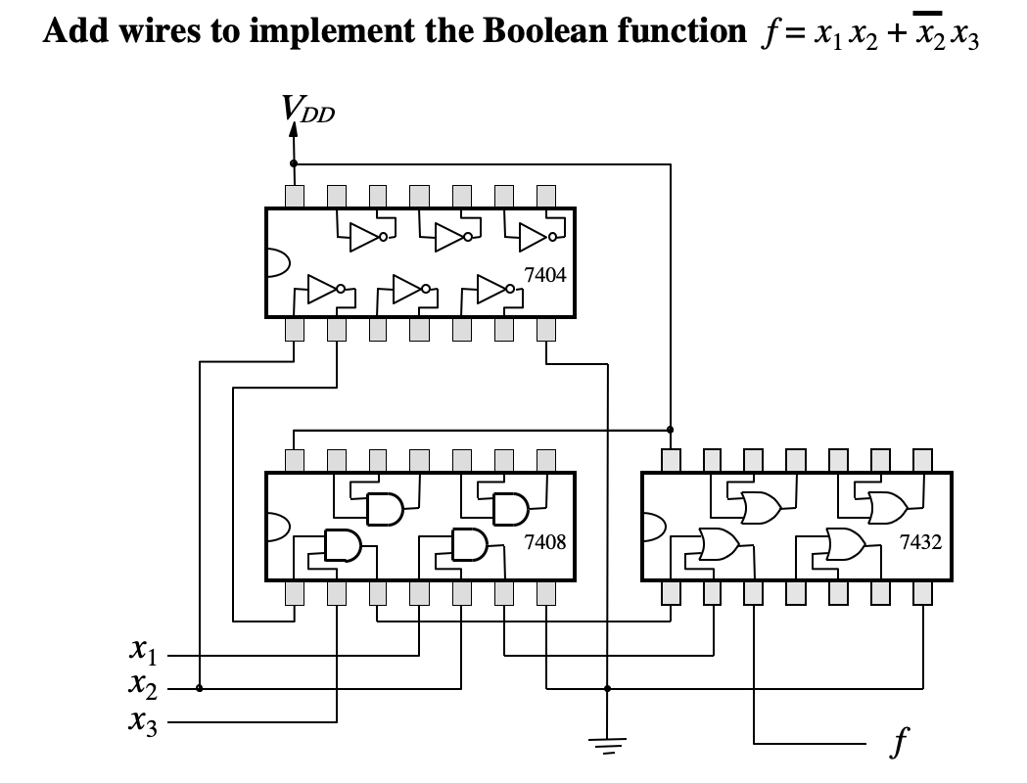

The 7404, 7408, and 7432 integrated circuits each contain multiple copies of one logic element. The 7404 contains 6 NOT gates, the 7408 contains 4 AND gates, and the 7432 contains 4 OR gates. When wired together, you can create a complex circuit. Each of these chips also has a V+ (5V or 3.3V) pin in the upper-left corner (in this figure) and a V- (ground) pin in the lower-right corner to provide power. Take a moment to verify that this circuit matches the circuit diagram on the previous page.

2.2 Human Interaction

We will use a set of DIP switches and an LED (light emitting diode) to test the circuit:

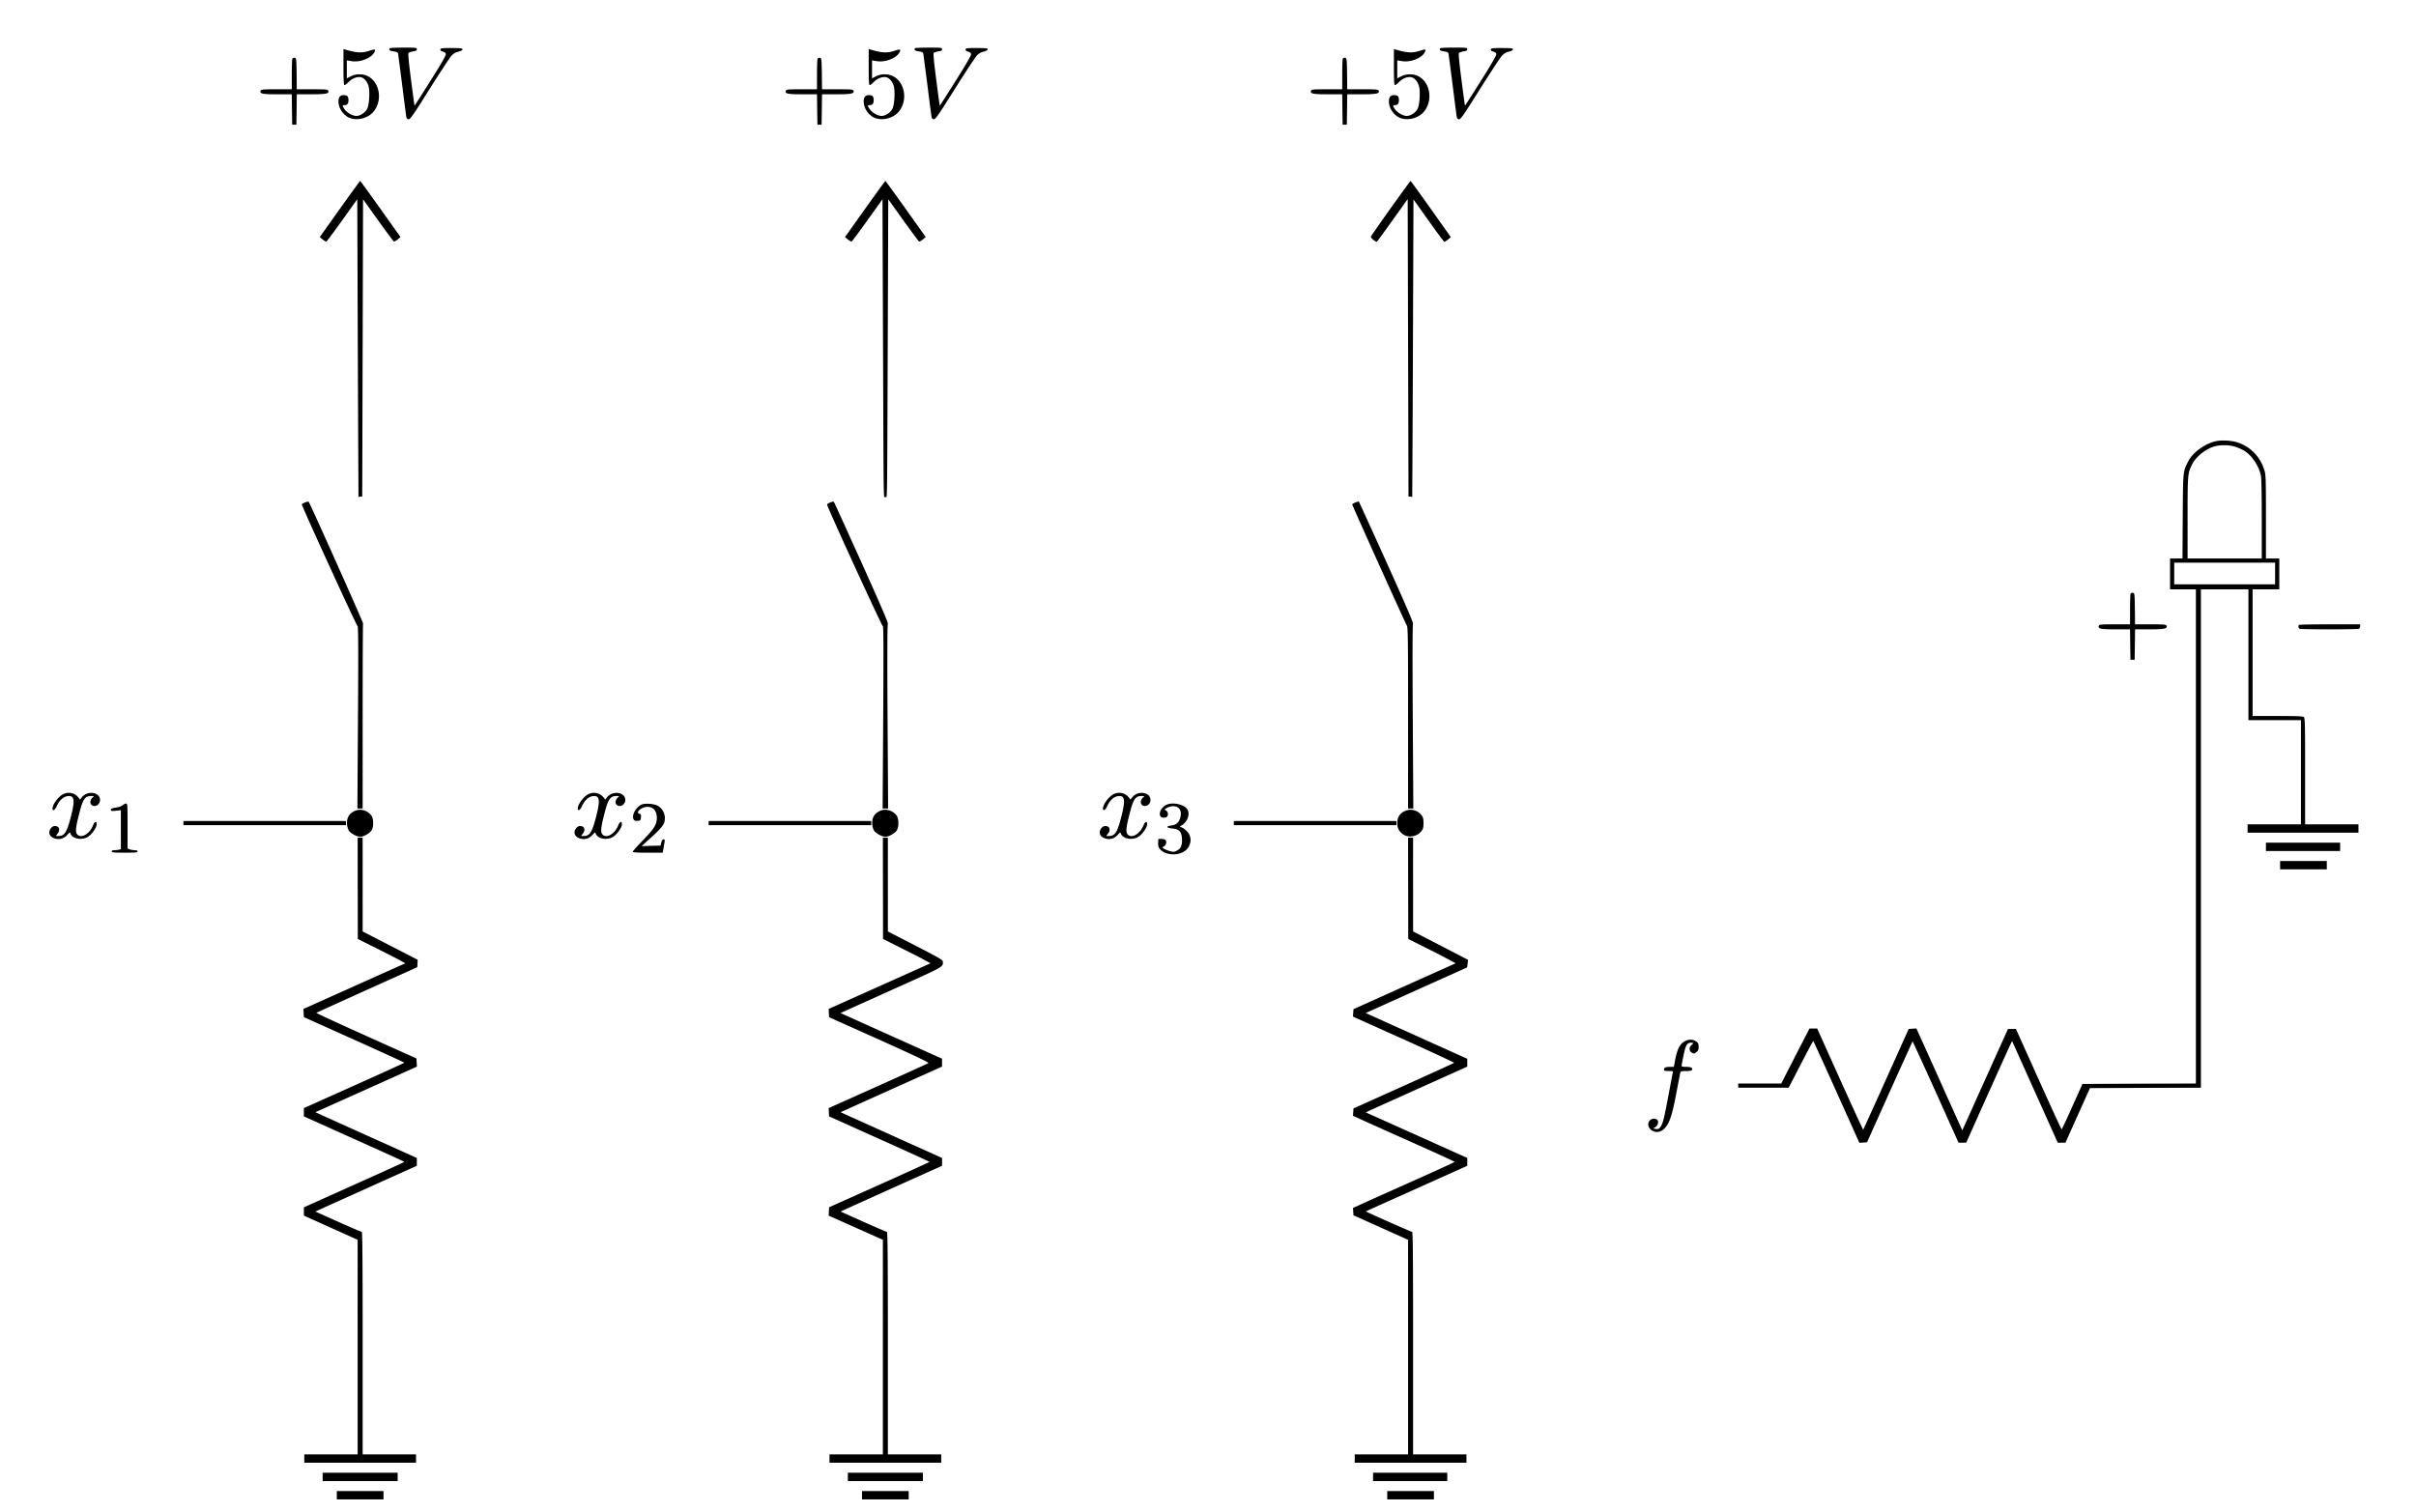

The details of why these resistors are required will be explained later if you take EE 201.

2.3 The Breadboard

The breadboard contains a field of pins for you to connect components. There are two sets of power rails (two pairs of + and – ). The pins on each (+) rail are connected vertically on this image. The same is true for the pins on the (–) rail. The pins in the center of the breadboard are connected in horizontal groups of five pins as shown below.

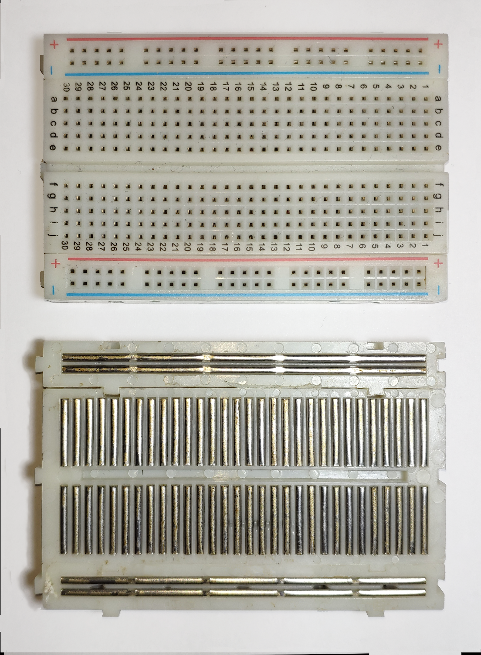

Front and back view of a breadboard. Image by Guhuru - Own work, CC0, https://commons.wikimedia.org/w/index.php?curid=97240411

Here is another view of the internal connections of a larger breadboard, that has been rotated by 90 degrees relative to the previous image. This one also has a power supply.
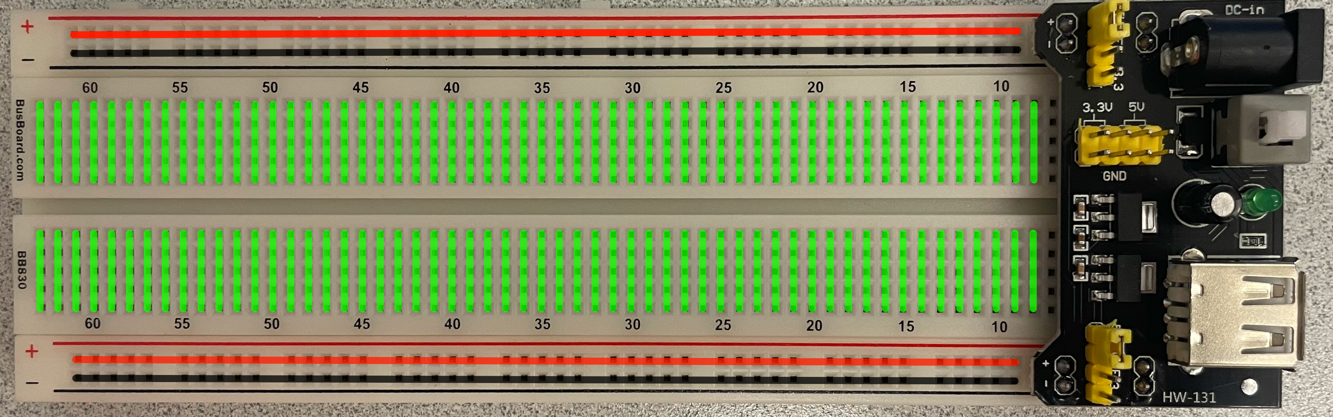

3.0 Assembly

1) Start with an empty breadboard. Please ensure that the + and – on the breadboard rails match the + and – on the power supply (shown on the right side). If the breadboard and the power supply are connected properly, then you should be able to read the numbers in decreasing order (60, 55, 50 , …. 15, 10). Do not plug in the power for the board yet.

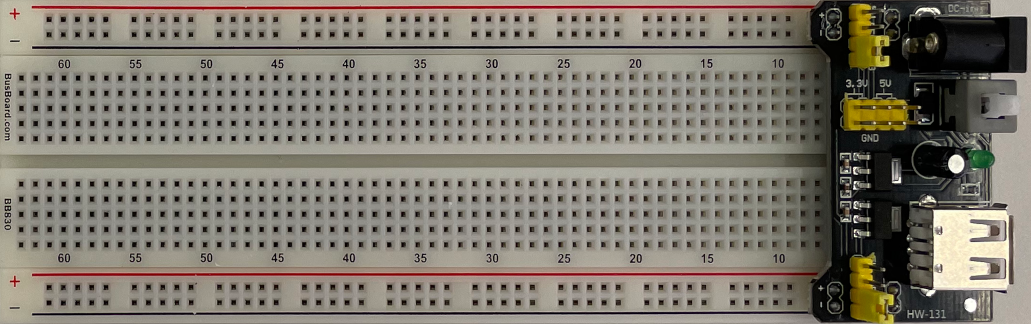

2) Insert the red switch box (i.e., the 5-position DIP switch). Order the chips from left to right as follows: NOT, AND, OR. The correct chip can be identified by reading its markings on the top and ignoring the letters. The pins of the chips should straddle the centerline of the breadboard. The semicircular cutouts of all chips should point to the left.

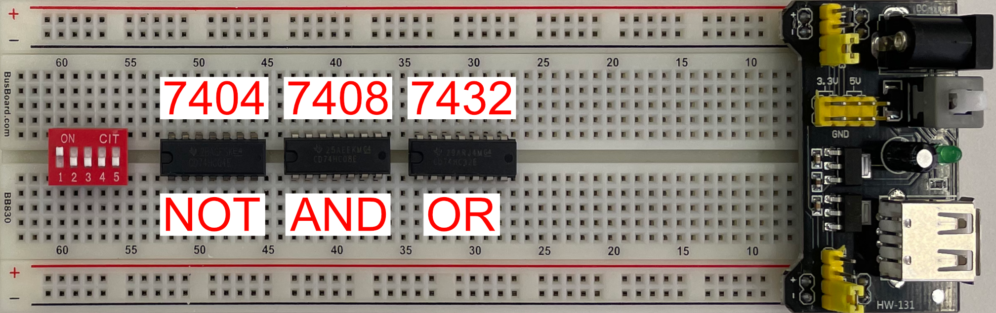

3) Connect the top part of the first three switches to the positive power rail. Then, connect each chip to the positive rail above it (use the pin in the upper-left corner) and the negative rail below it (use the pin in the lower-right corner) as shown in this figure:
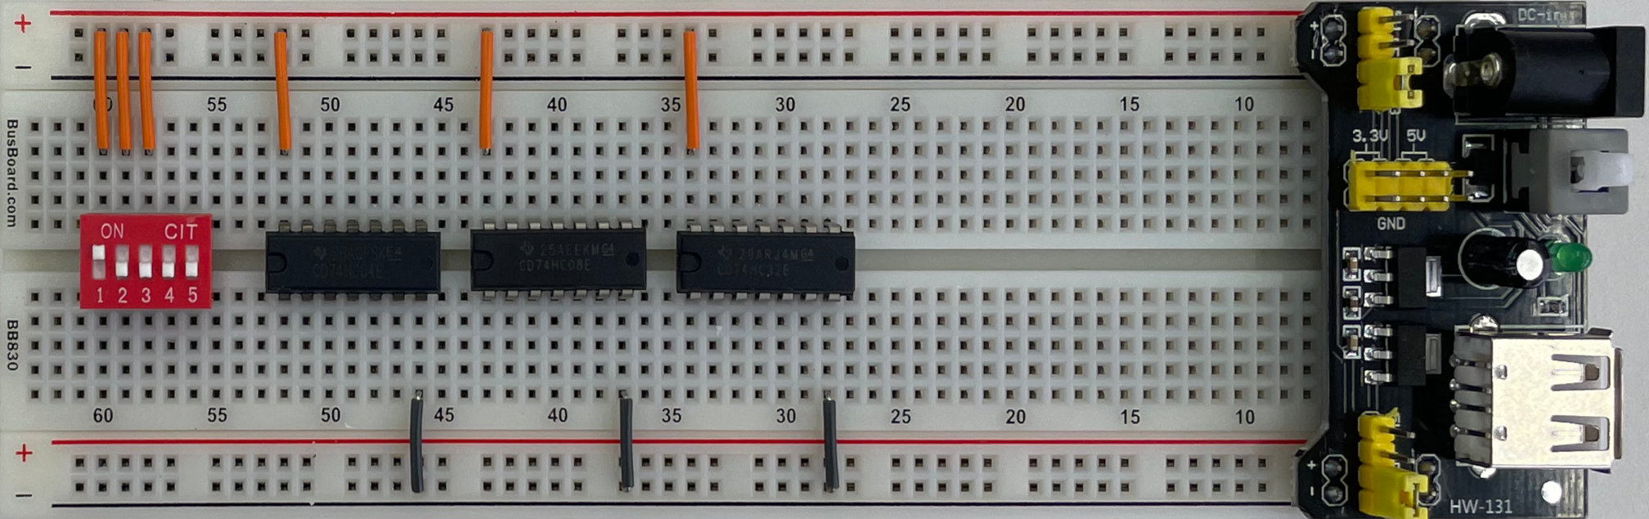
4) Connect the inputs and outputs of the logic gates from the three chips to match the circuit diagram shown on page 2. Pick appropriate length wires for this task and make sure to connect the correct pins. You can leave the unused pins hanging, i.e., not connected to anything. The colors of the wires don’t matter (it is just the insulation), but they could help you to debug the circuit more easily.

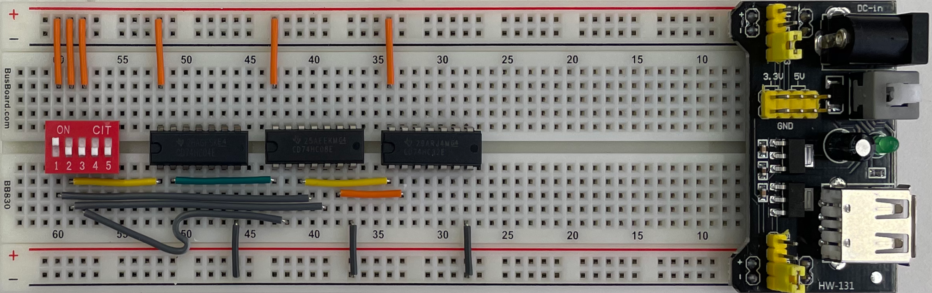

5) Connect the bottom of the first three switches to ground using three resistors. Then, add the fourth resistor and the LED. Ensure that the long end of the LED is connected to the resistor and that the short end is connected to the ground (–) rail.

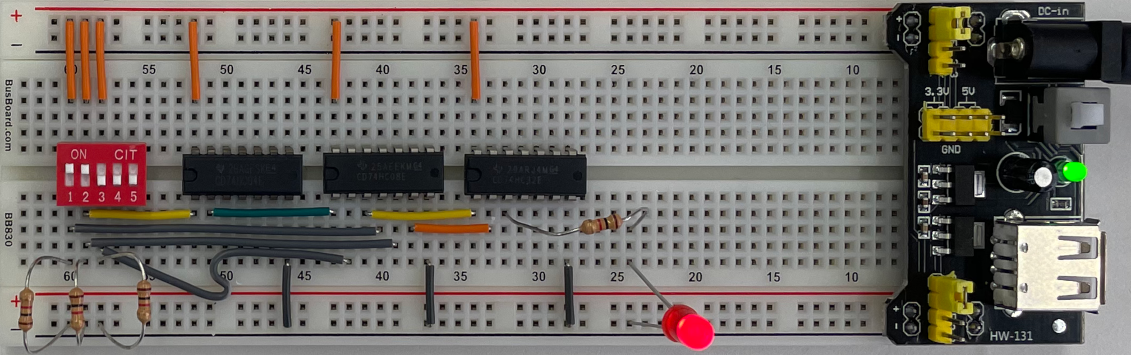

6) Important: Ask a TA to verify your circuit. Do not proceed or power the breadboard until the TA confirms that your circuit is ready for testing.

Then, unplug your DES-115 board and connect its power cable to your breadboard (it should fit because they use the same power supply jack). If it does not turn on, press the white power button on the black power supply board. Flip the first three switches and verify that the output of the LED matches the truth table for all eight rows. The convention is that “light” means 1, and “no light” means 0. The truth table is shown on page 1.

4.0 Multimeter Testing
The LED shows the output of the final circuit, but you can also use a multimeter to investigate the intermediate outputs of the logic gates. Turn on your multimeter by pressing the red ON/OFF button, turn the circular dial in the center to the 20V marker, then connect the black lead to the ground rail of the breadboard.

Carefully insert the red lead into any location on the breadboard to measure the voltage. Do not accidentally touch two separate pins with the red lead at the same time. The two images below show the output of the first NOT gate when switch 2 is toggled up and down, respectively. Notice that the measured voltage is 0V when the switch is on (up), and approximately 5V when the switch is off (down).
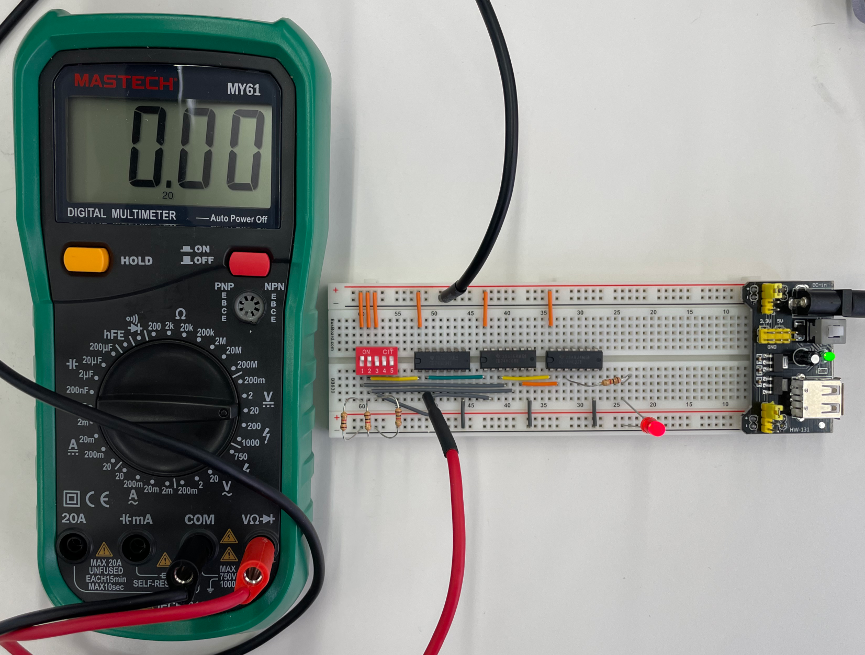

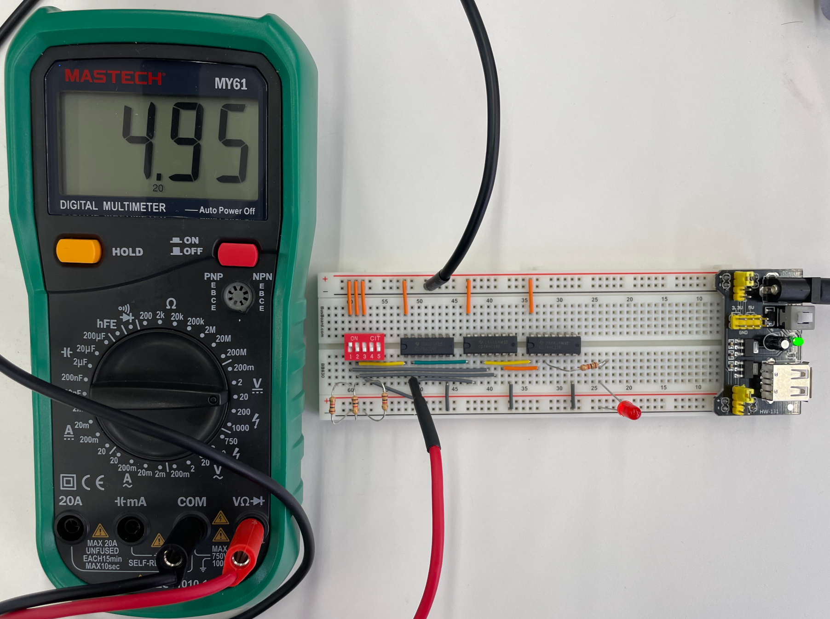
This breadboard power supply can also be configured to generate 3.3V instead of 5V for the circuit. To test this feature, turn off your circuit by pressing the white power button and unplugging the power cord. Then, pull off the two yellow connectors (“jumpers”) and move them over as shown below:

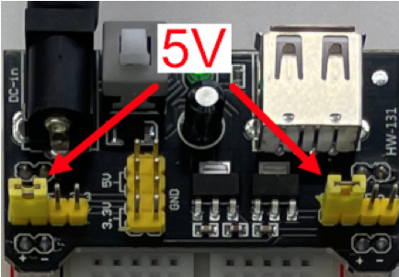 |  | 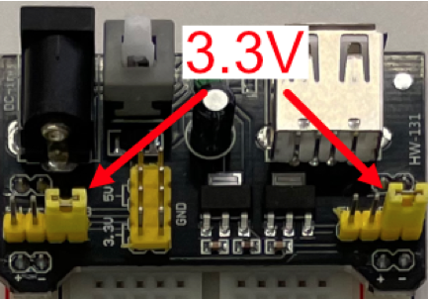

After moving the jumpers, power on your circuit again and the multimeter should now show about 3.3V instead of 5V.

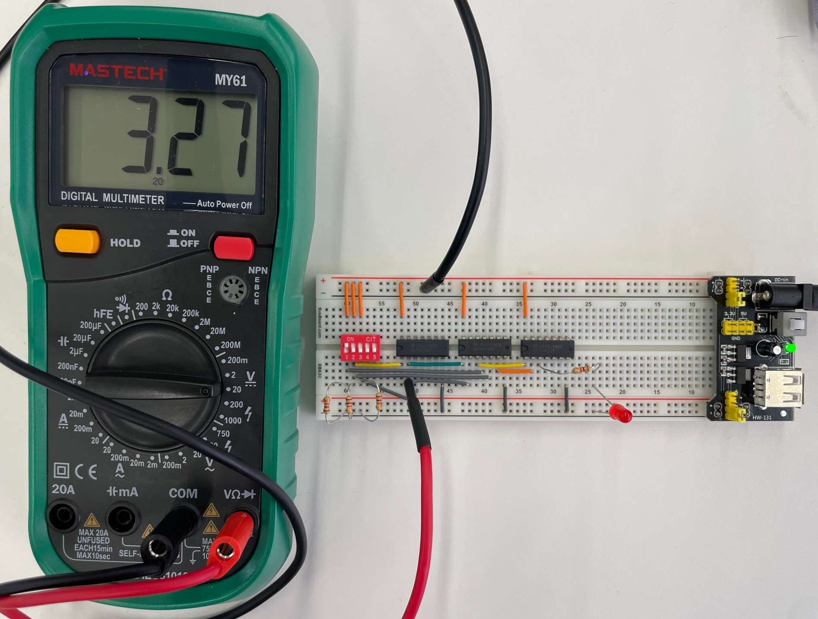
5.0 Bill of Materials

1 – Breadboard
1 – Wire Box
1 – 5-Position DIP Switch
1 – LED
4 – 1kΩ Resistors
1 – 5/3.3V Power Supply
1 – 7404 NOT gate
1 – 7408 AND gate
1 – 7432 OR gate
1 – Multimeter

