Cpr E 281 LAB  Electrical and Computer Engineering  Iowa State University | Implementing a 4-bit Add/Subtract Unit with Physical Gates

Objective

In the last TTL lab, you used CMOS integrated circuits with AND, OR, and NOT gates to build a simple logic circuit. In this lab, you will be using a CMOS chip that contains 4 XOR gates and another CMOS chip that is a 4-bit adder to create a 4-bit add/subtract unit.

The inputs to your circuit will be two four-bit binary numbers X=X₃X₂X₁X₀ and Y=Y₃Y₂Y₁Y₀. The Add/Sub input causes the XOR gates to invert the Y inputs and sets the carry c₀ high, effectively adding X to negative Y (following the rule for 2s-complement negation: “invert every bit and then add one”).

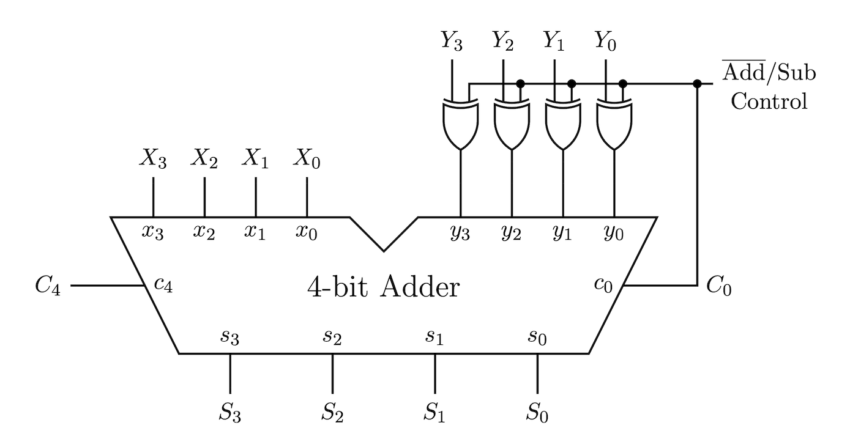

2.0 Pin Diagrams

2.1 4-bit Adder (74283)

Download the datasheet for the 4-bit adder (i.e., CD54HC283) from this link:

https://www.ti.com/lit/ds/symlink/cd54hc283.pdf

The pinout for the adder is shown on page 3 of that PDF file and also replicated below (see the left image). This datasheet uses A[0:3] and B[0:3] to represent the two 4-bit inputs. It also uses Cin to represent c₀ and Cout to represent c₄. The output sum pins are labeled with S[0:3]. Pin 16 is the positive power supply (Vcc) and pin 8 is ground.

Notice that the labels for the pins are different from the labels that we want to use for our circuit. The data sheet uses A and B, but we need x and y. While this is just a relabeling issue, it could slow you down and lead to wiring errors if you are not careful. Therefore, we will use the right image, which renames the pin labels to what we need and switches from capital to small letters.

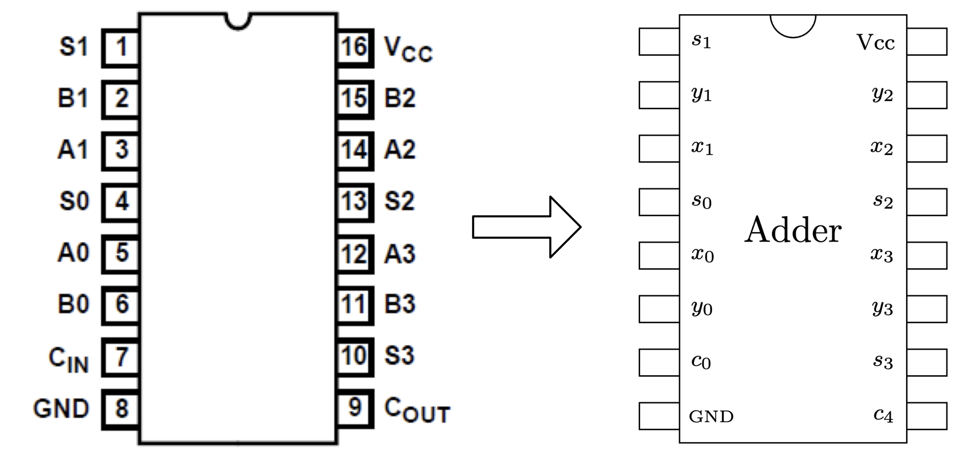

2.2 XOR gate (7486)

Download the datasheet for the XOR chip (i.e., CD74HC86) from this link:

https://www.ti.com/lit/ds/symlink/cd74hc86.pdf

The first page of the datasheet shows the pinout for this chip. However, that diagram starts the counting at 1 instead of 0. This could be very confusing for beginners and could lead to a lot of wiring errors, so we will not use it directly. Instead, we will use the diagram on the right, which uses 0-based indexing for the inputs and outputs. It also switches to lower case letters to be consistent with the rest of the circuit.

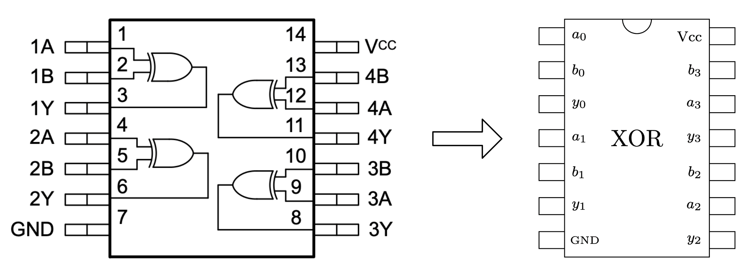

2.3 Overall Wiring Diagram

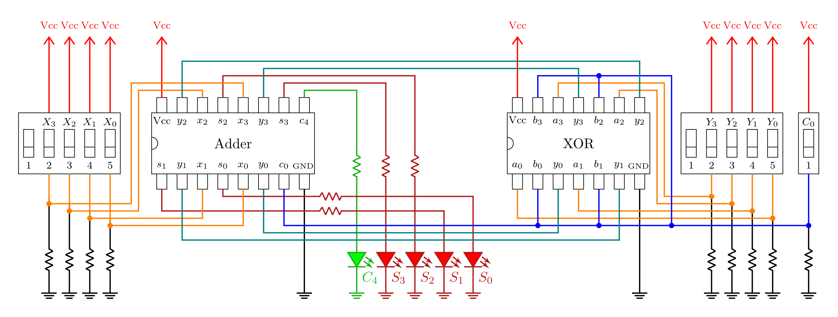

3.0 Assembly

1) Start with an empty breadboard. The power supply should be on the right and the numbers on the breadboard should be in decreasing order (60, 55, 50, etc.). Check that the + and – rails of the breadboard match the + and – of the power supply (black board). Verify that the two yellow jumpers on the power supply are set to +5V (see the image below). Do not plug in the power cable yet.

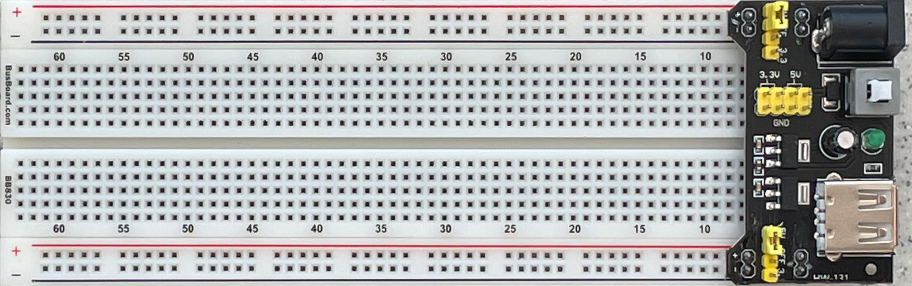

2) Insert the DIP switches, XOR IC, and the 4-bit adder. Ensure the correct IC is in each slot, each IC can be identified by reading the markings on the top and ignoring the letters. Make sure the semi-circular cutouts on the ICs all point to the left.

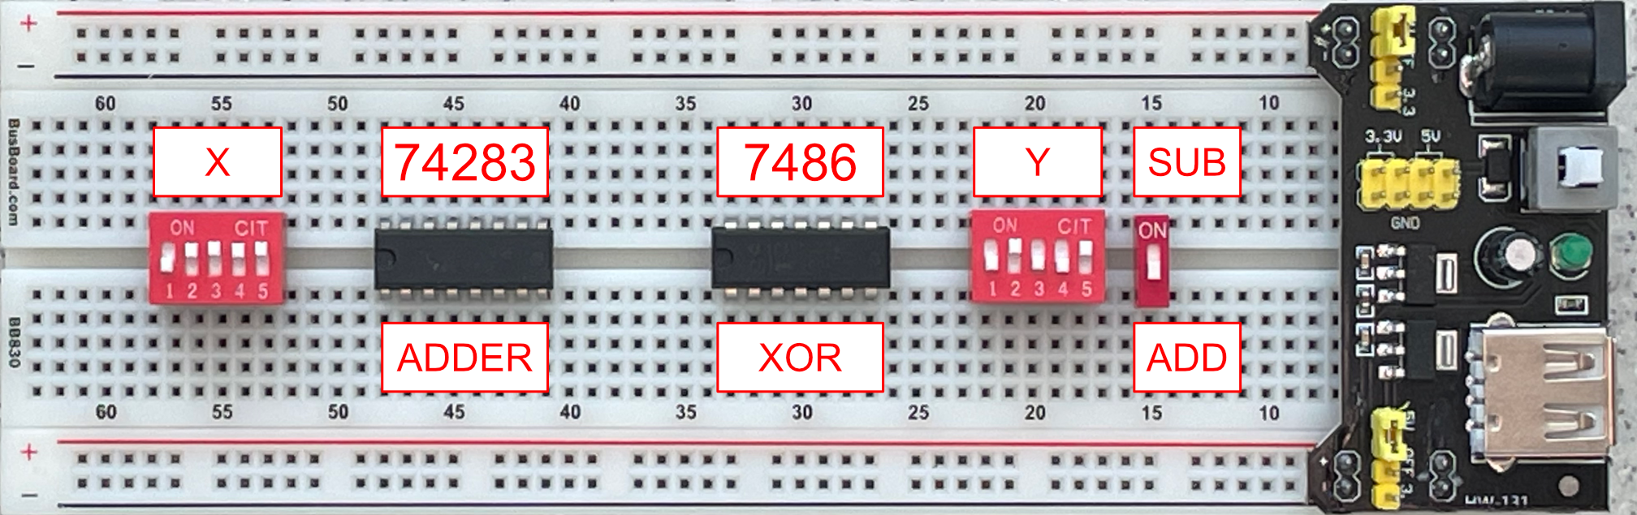

3) Connect the power and ground pins of each of the ICs and the DIP switches. Note that we are using switches 2-5, nothing should be connected to switch 1.

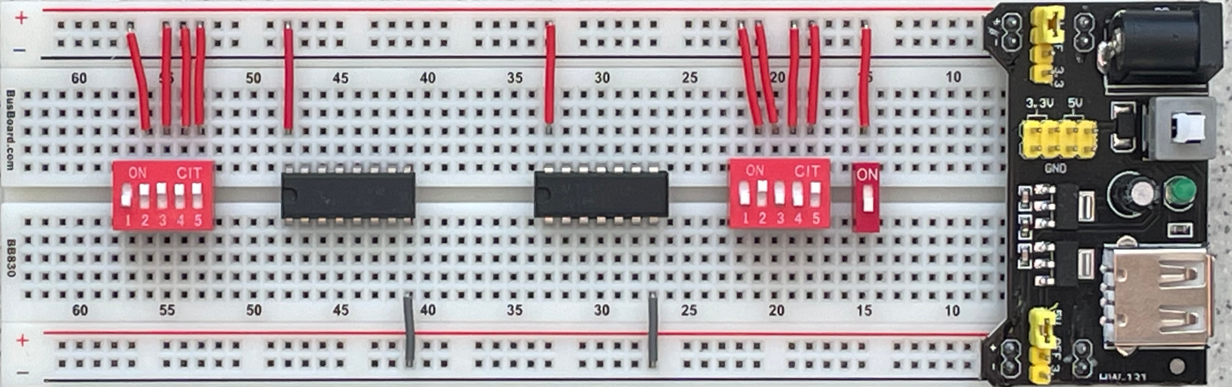
4) Connect the gate inputs and outputs together following the overall circuit diagram.

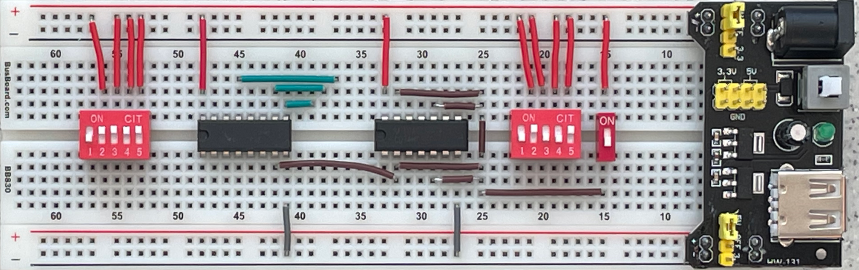

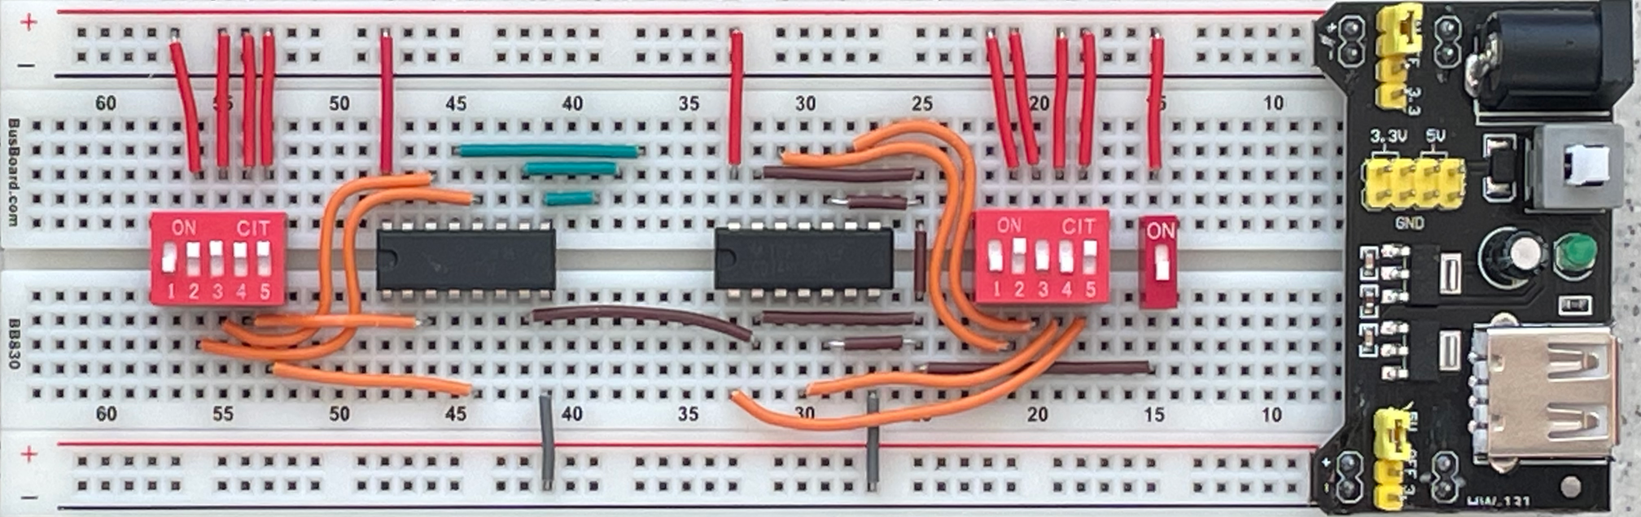

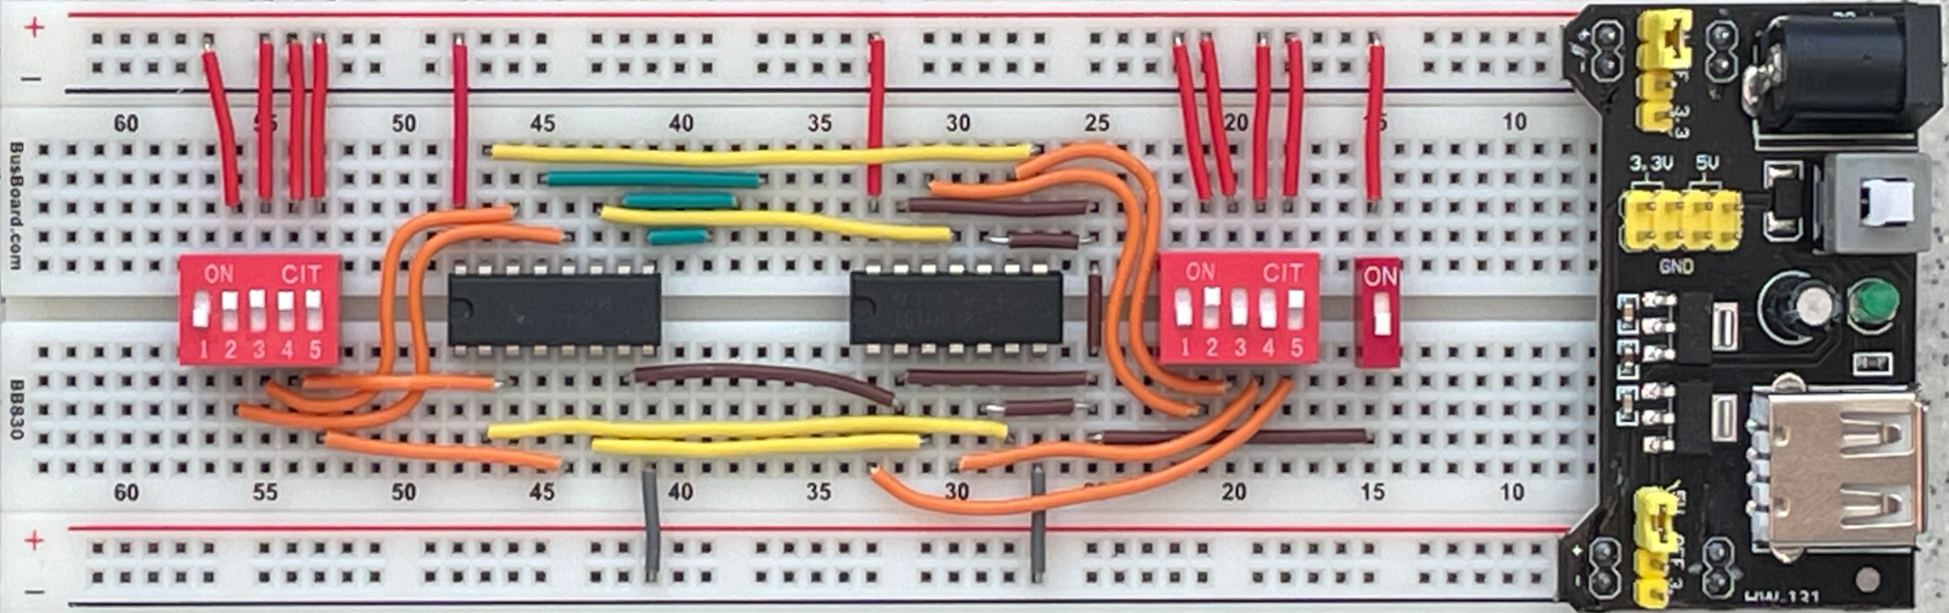

5) Connect the switches to ground using resistors and add the resistors for the LEDs. Because of the complexity of the circuit, we have trimmed the legs of some resistors in these pictures. Yours will be longer. Ensure that the long end of each LED is connected to a resistor and the short end to the – rail.

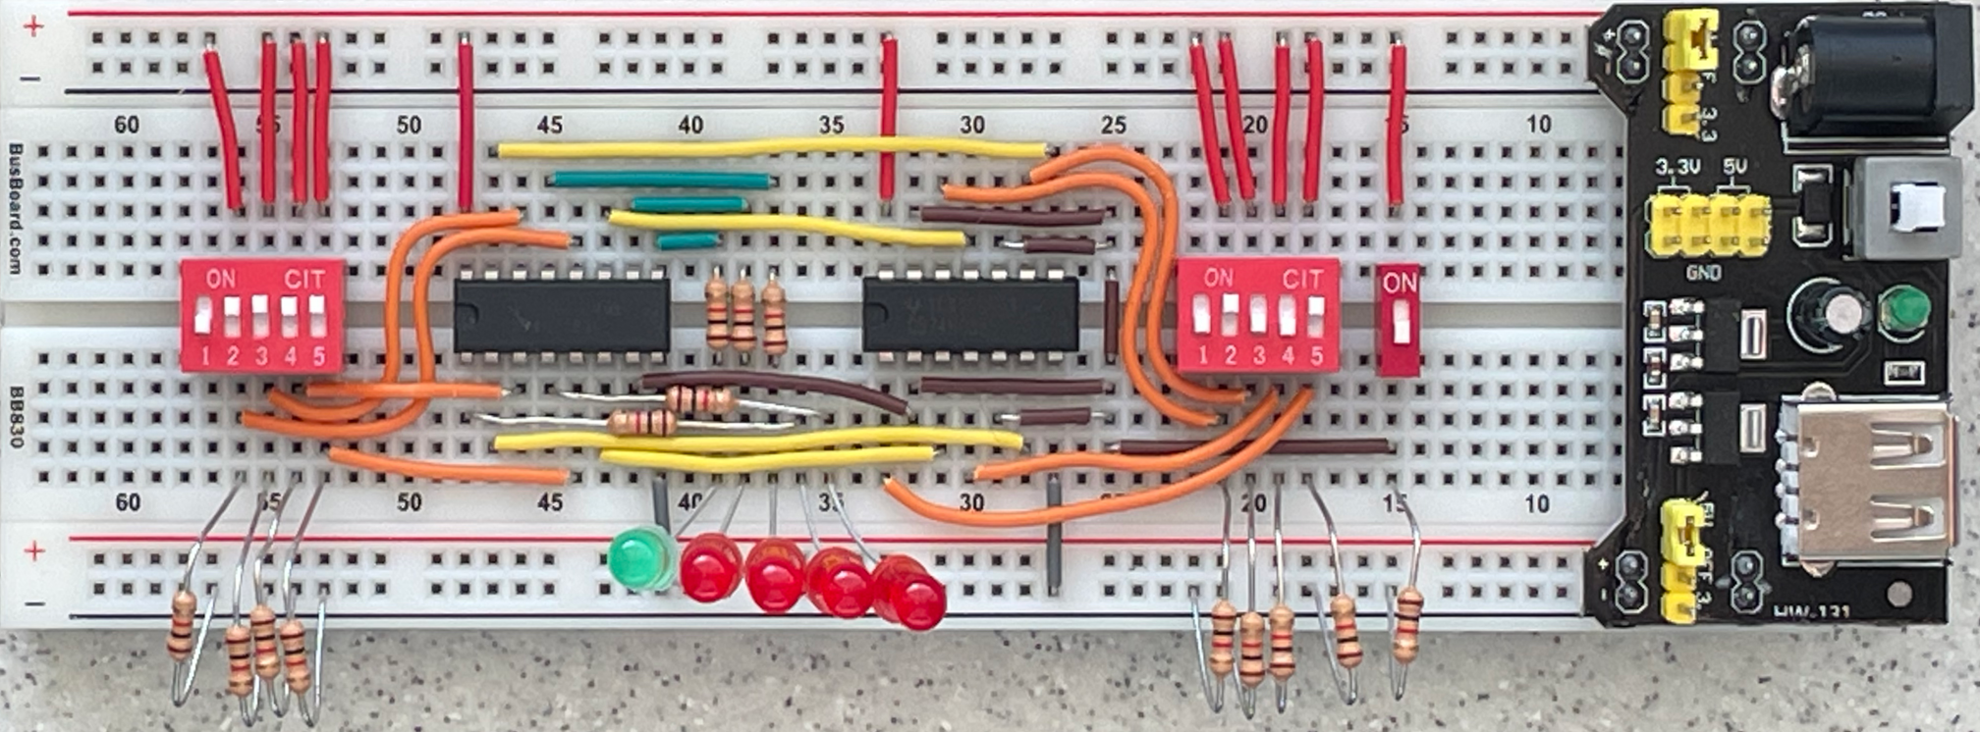

6) Verify that the connections in your circuit match the wiring diagram shown here:

7) Ensure that the legs of the resistors are not touching. Ask a TA to verify your circuit, then unplug your DES-115 board and connect its power cable to your breadboard. If it does not turn on, press the white power button on the power supply board. Flip the DIP switches and verify that the LED output matches the expected result.
4.0 Verification
With the circuit complete, you can now plug in the breadboard and test your new adder. Use switches 2-5 on X (left side) and Y (right side) to ensure the adder works correctly. Once you are satisfied that the adder works, flip the add/sub switch to change the adder into a subtractor and verify that the XOR gates and carry 0 work correctly.

Example: 3 + 2 = 5

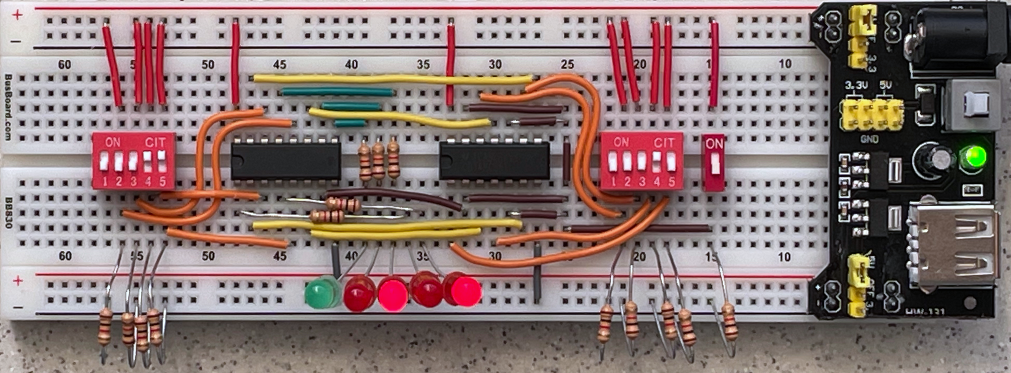

Example: 3 – 2 = 1

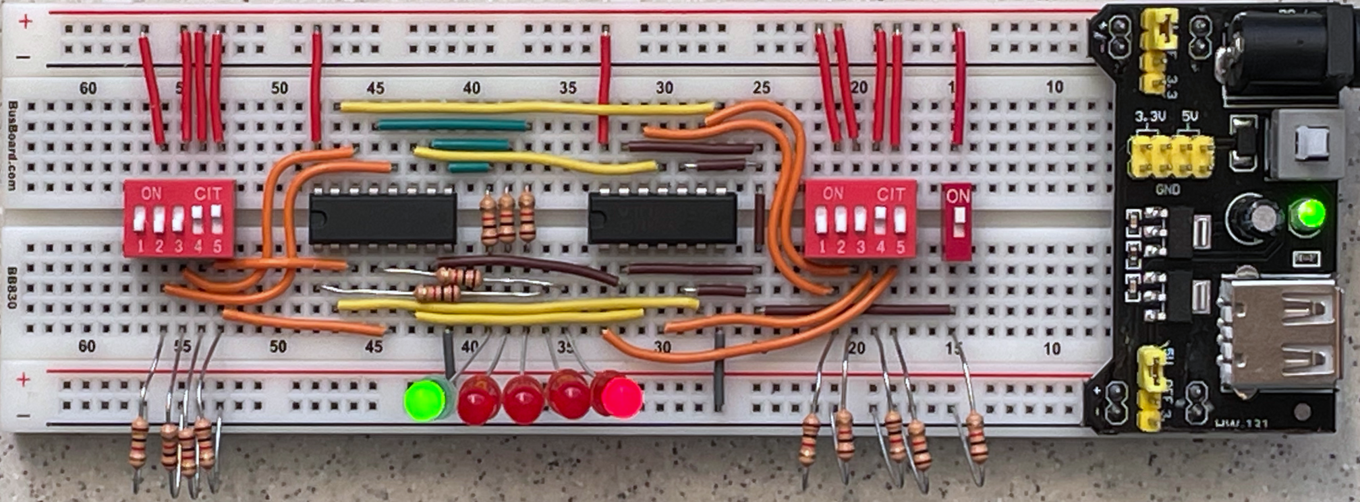

5.0 What to submit?

Take at least two pictures of your circuit performing one addition and one subtraction (these should be similar to the ones above, but you can pick different numbers). Put these pictures into a Word document. At the top write your name and the name of your project partner. Convert the Word file to PDF and then upload the PDF on Canvas under “Lab6”.
The pictures must clearly show the state of the switches and the LED output. Each student in the team must upload a file.

