CprE 281 Lab Online Access
VDI provides a virtual Windows 10 or Linux desktop with the same software as our physical computer labs. VDI works both on-campus and off-campus and can be used from almost any computing device (https://etg.ece.iastate.edu/vdi/).

How to connect to VDI:
If you are off campus you no longer need to connect to the VPN before using VDI (unless you want to; instructions for VPN are posted here: https://vpn.iastate.edu/).

- Download the client for Windows or Mac: https://vlab.ece.iastate.edu/
- Install the client with all the defaults.
- Launch the VMware Horizon Client
- Click the New Server icon on the Horizon Client Home window (the plus button on the top left), enter https://vlab.ece.iastate.edu for the name of the Connection Server, and click Connect.
- Enter your IASTATE NetID and password
- Double click on CPRE (See the image below). Do not use EE or any of the others as they do not have the correct software installed.

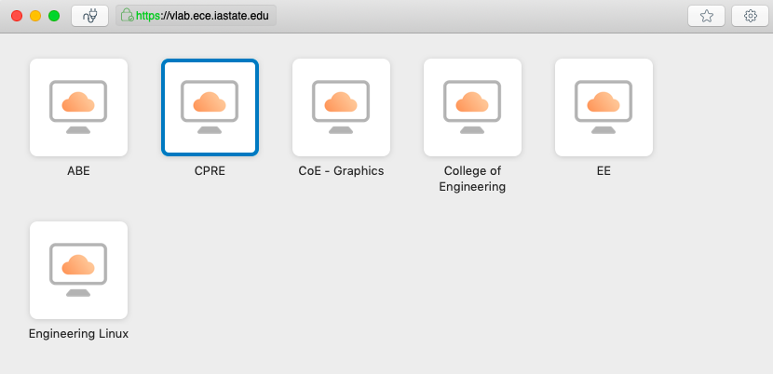

You should now be able to access Quartus Prime remotely, as well as your U: drive. When you are finished using the VDI session, make sure anything that you want to keep saved on your U: drive. Otherwise, it will be deleted after you logout. You can exit the VDI session via several methods:
- Start Menu > Log off
- Start Menu > Shut Down
- Quit the VMware View Client

All sessions are automatically destroyed after 2 hours of inactivity or logoff/shutdown.

Alternatively, you can use VMware from your browser by clicking on
"VMware Horizon HTML Access" in this page: https://vlab.ece.iastate.edu/

